 | Autumn Term |  | Spring Term |  | Summer Term
EYFS | 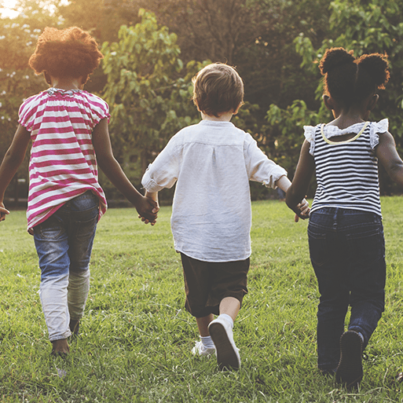  Me and My Community  In this project, children explore their family history and look at how they have changed since being babies. Children look at the vocabulary of time. They learn about the lives of people in their community and society. | 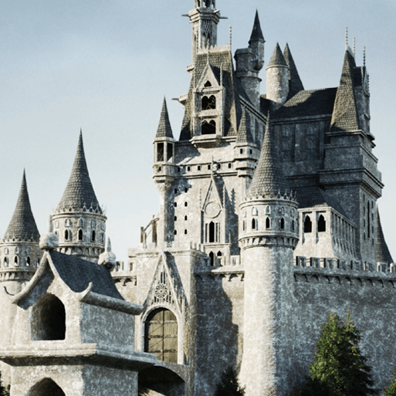  Once Upon A Time  In this project, children are introduced to the theme of monarchy and royalty and find out about kings and queens in stories. They begin to compare life in the past with their lives by looking at artefacts. |   Starry Night  In this project they are introduced to significant historical figures and events when they learn about Neil Armstrong and the first moon landing. | 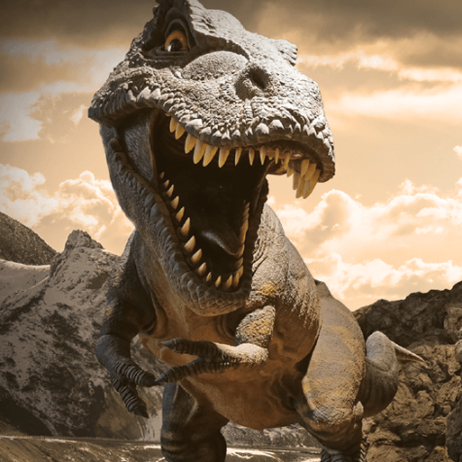  Dangerous Dinosaurs  This exciting project teaches children about the different animals that roamed Earth millions of years ago and how they are related to animals that live on Earth today.  Blackpool Zoo - Dinosaurs | 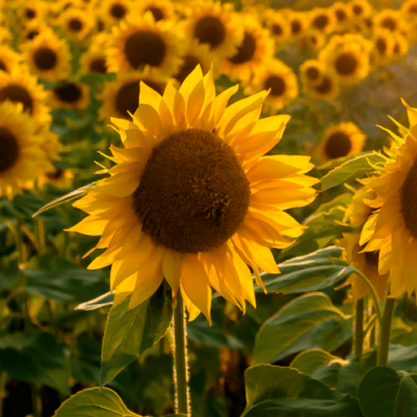  Sunshine & Sunflowers |   Big Wide World  In this project children learn about significant figures. They explore how life and transport were different in the past. They continue to learn about their family history and introduced to the concept of heritage.
Year 1 | 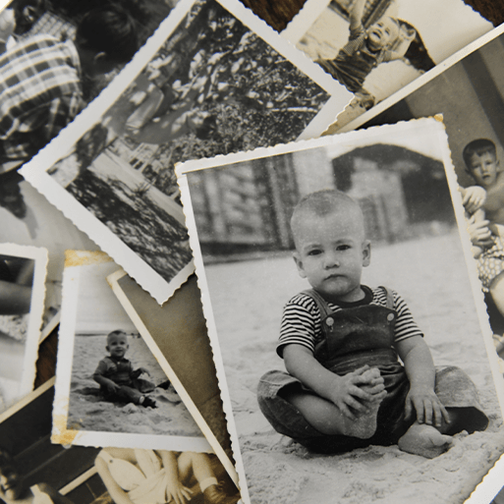  Childhood (H)  This project teaches children about everyday life and families today, including comparisons with childhood in the 1950s, using artefacts and a range of different sources.  Museum Visit – Toys |  | 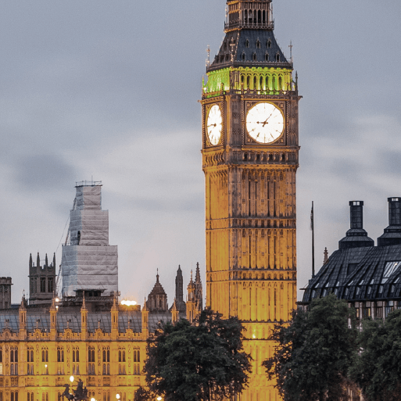  Bright Lights, Big City (G)  This project teaches children about the life of the monarch as a significant person. They learn about the Great Fire of London, its chronology and causes and consequences. They are introduced to the term ‘monument’ and begin to understand how monuments and memorials commemorate significant events.  Great Fire of London Workshop |  | 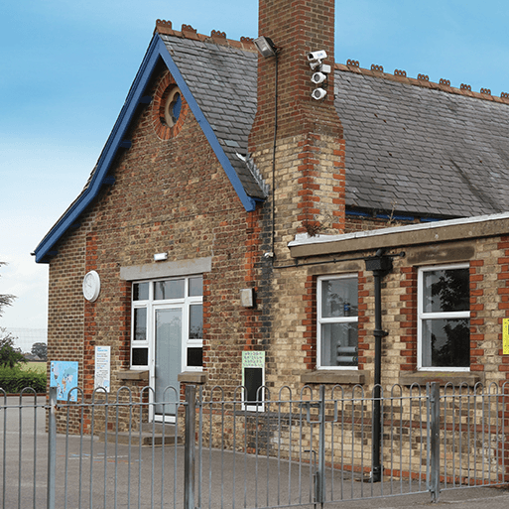  School Days (H)  This project teaches children about their own school and locality, both today and in the past. They compare schooling in the Victorian era to their experiences today.  Judges Lodgings Visit – Victorian School
Year 2 | 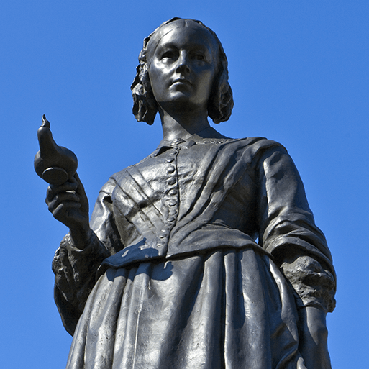  Movers and Shakers (H)  This project teaches children about historically significant people who have had a major impact on the world. They will learn to use timelines, stories and historical sources to find out about the people featured and use historical models to explore their significance.  Museum Visit – Local Significant People |  | 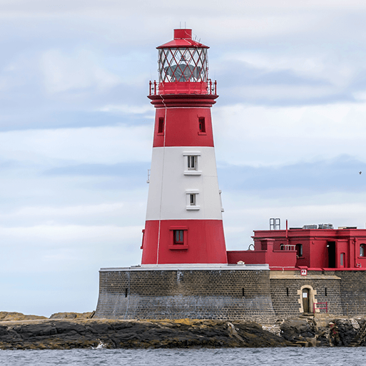  Coastline (G)  Pupils develop their historical learning about people’s everyday lives in the past, using images as sources of evidence. Introduced to the concepts of continuity and change, describing how Whitby has changed over time. Pupils learn about SS Rohilla disaster and the changes to the RNLI. They learn about coastal jobs in the past and learn about Captain James Cook and his impact on the world. |  | 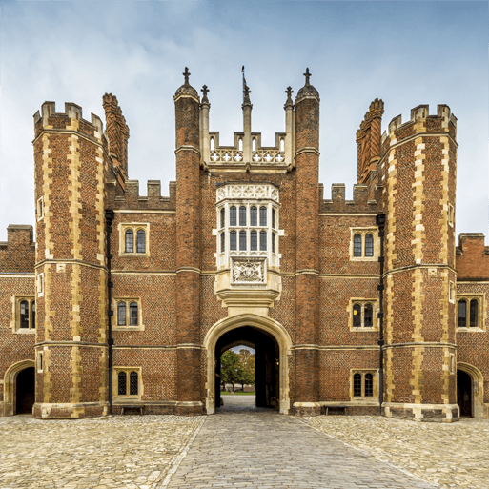  Magnificent Monarchs (H)  This project teaches children about the English and British monarchy from AD 871 to the present day. Using timelines, information about royal palaces, portraits and other historical sources, they build up an understanding of the monarchs and then research six of the most significant sovereigns.  Clitheroe Castle Visit
Year 3 | 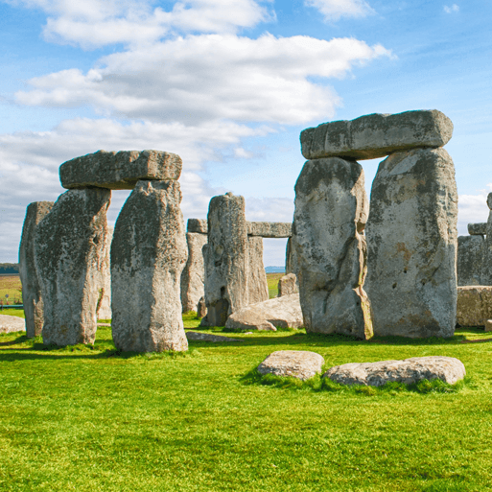  Through the Ages(H)  This project teaches children about British prehistory from the Stone Age to the Iron Age, including changes to people and lifestyle caused by ingenuity, invention and technological advancement.  Outdoor Elements – Stone Age Workshop |  | 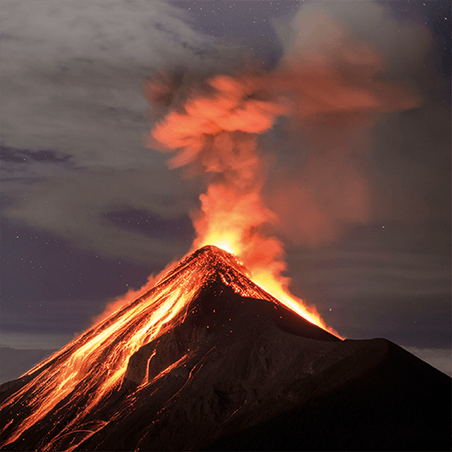  Rocks, Relics and Rumbles(G)  In this project children revisit Mary Anning and learn about her prehistoric discoveries and how her legacy has made her a significant person in history. Children are introduced to the concept of cause and effect by studying significant event – the destruction of Pompeii and the eruption of Mount Vesuvius. They develop their understanding of the role of archeology (Giuseppe Fiorelli). |  | 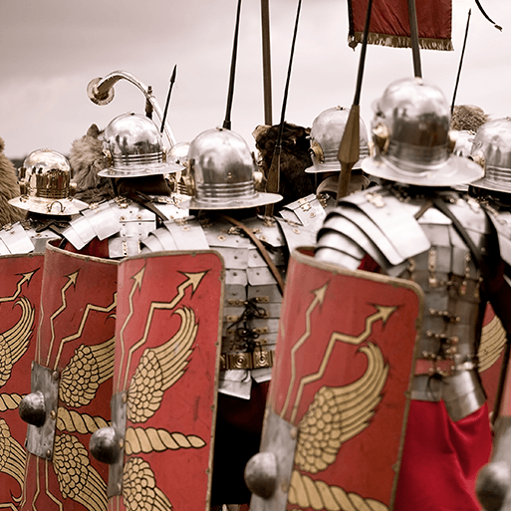  Emperors and Empires(H)  This project teaches children about the history and structure of ancient Rome and the Roman Empire, including a detailed exploration of the Romanisation of Britain.
Year 4 | 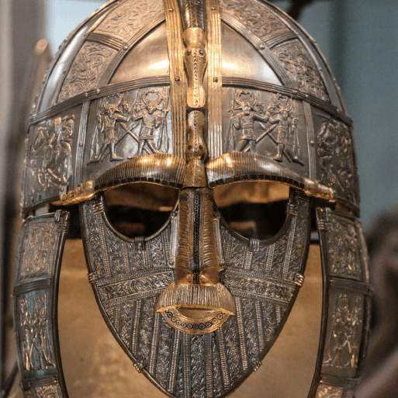  Invasion(H)  This project teaches children about life in Britain after the Roman withdrawal. Children will learn about Anglo-Saxon and Viking invasions up to the Norman conquest.  Viking Workshop |  | 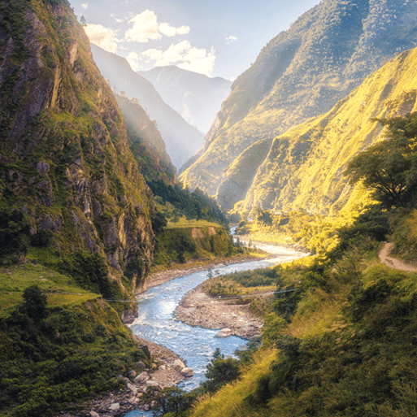  Misty Mountain, Winding River(G)  Ribchester Museum Visit |  | 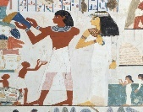  Ancient Civilisations(H)  This project teaches children about the history of three of the world’s first ancient civilisations: ancient Sumer, ancient Egypt and the Indus Valley civilisation. Children will learn about the rise, life, achievements and eventual end of each civilisation.  Ancient Civilisation Workshop
Year 5 | 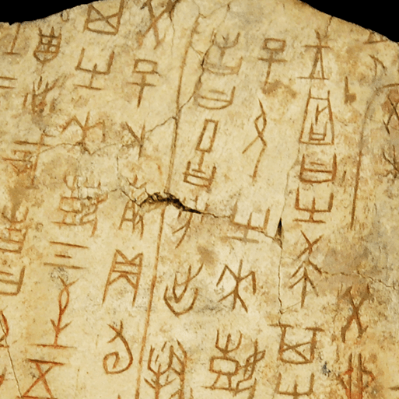  Dynamic Dynasties(H)  This project teaches children about the history of ancient China, focusing primarily on the Shang Dynasty, and explores the lasting legacy of the first five Chinese dynasties, some of which can still be seen in the world today. |  | 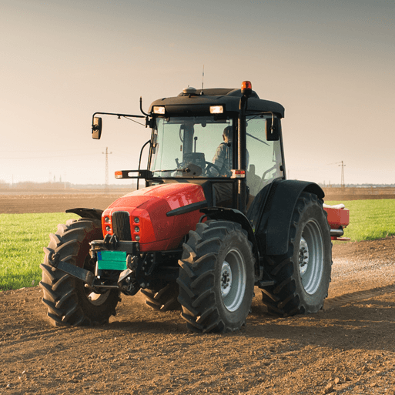  Sow, Grow, Farm(G)  This project teaches children to learn about the historical campaign ‘Dig for Victory ‘from WW2 using a range of sources. They learn about the principles behind it and the importance of people growing food to support the war effort. |  | 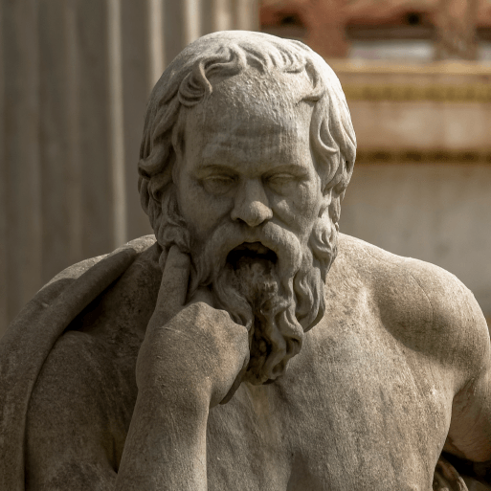  Groundbreaking Greeks(H)  This project teaches children about developments and changes over six periods of ancient Greek history, focusing on the city state of Athens in the Classical age, and exploring the lasting legacy of ancient Greece.  Liverpool Walker Art Gallery
Year 6 | 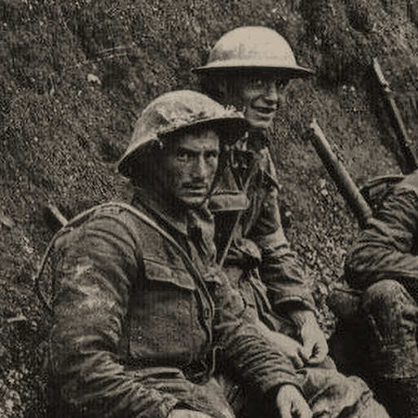  Britain at War(H)  This project teaches children about the causes, events and consequences of the First and Second World Wars, the influence of new inventions on warfare, how life in Great Britain was affected and the legacy of the wars in the post-war period.  Visitor to talk about the Spitfire during the War |  | 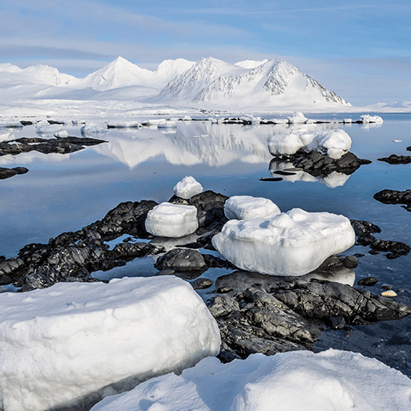  Frozen Kingdom(G)  This project builds on the concept of exploration from Y2 and children learn about the significant achievements of explorers who sailed to polar regions using their knowledge of chronology to build a timeline. They study Scott on his expedition to the South Pole and causes and consequences. They study Shackleton and his team as well as learning about the sinking of the Titanic. |  | 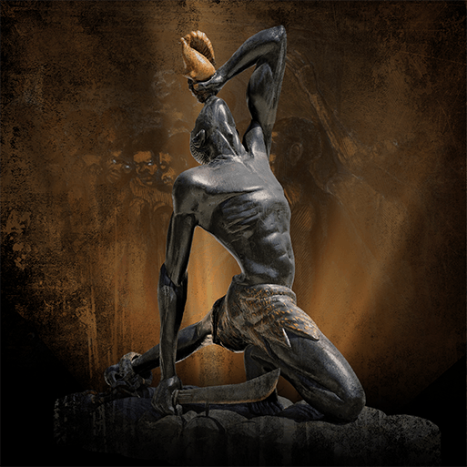  Maafa(H)  This project teaches children about Africa past and present and the development of the slave trade. It also explores Britain’s role in the transatlantic slave trade, the causes and consequences of the European colonisation of Africa and the worldwide communities that make up the African diaspora.  Liverpool Museum on slavery

