Autumn | Spring | Summer
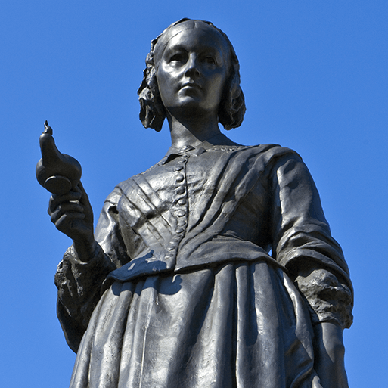  Movers and Shakers (H)  This project teaches children about historically significant people who have had a major impact on the world. They will learn to use timelines, stories and historical sources to find out about the people featured and use historical models to explore their significance.  Museum Visit – Local Significant People | 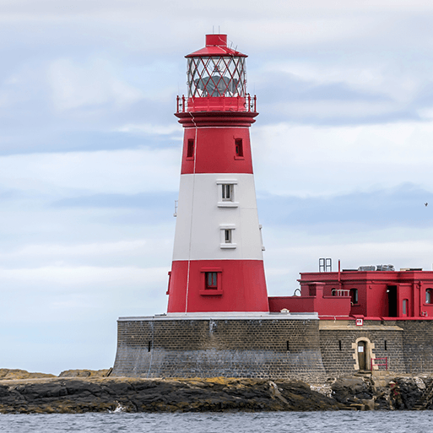  Coastline (G)  Pupils develop their historical learning about people’s everyday lives in the past, using images as sources of evidence. Introduced to the concepts of continuity and change, describing how Whitby has changed over time. Pupils learn about SS Rohilla disaster and the changes to the RNLI. They learn about coastal jobs in the past and learn about Captain James Cook and his impact on the world. | 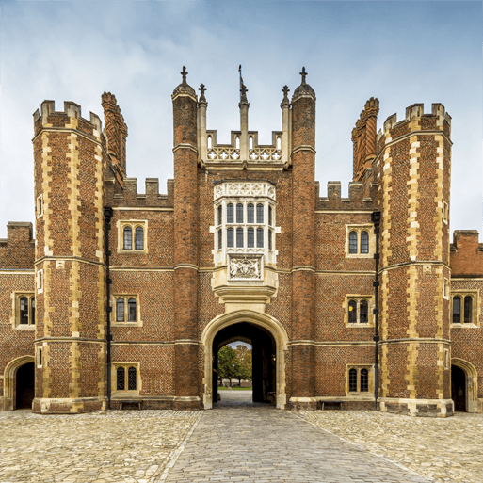  Magnificent Monarchs (H)  This project teaches children about the English and British monarchy from AD 871 to the present day. Using timelines, information about royal palaces, portraits and other historical sources, they build up an understanding of the monarchs and then research six of the most significant sovereigns.  Clitheroe Castle Visit

