Autumn | Spring | Summer
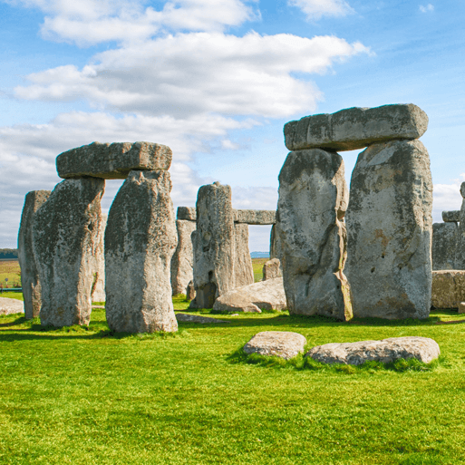  Through the Ages (H)  This project teaches children about British prehistory from the Stone Age to the Iron Age, including changes to people and lifestyle caused by ingenuity, invention and technological advancement.  Outdoor Elements – Stone Age Workshop |   Rocks, Relics and Rumbles (G)  In this project children revisit Mary Anning and learn about her prehistoric discoveries and how her legacy has made her a significant person in history. Children are introduced to the concept of cause and effect by studying significant event – the destruction of Pompeii and the eruption of Mount Vesuvius. They develop their understanding of the role of archeology (Giuseppe Fiorelli). | 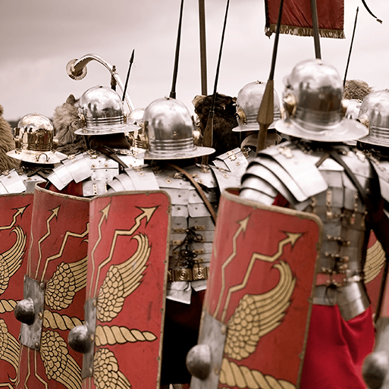  Emperors and Empires (H)  This project teaches children about the history and structure of ancient Rome and the Roman Empire, including a detailed exploration of the Romanisation of Britain.

