Autumn | Spring | Summer
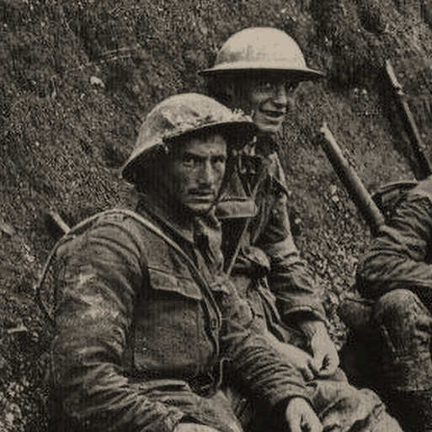  Britain at War (H)  This project teaches children about the causes, events and consequences of the First and Second World Wars, the influence of new inventions on warfare, how life in Great Britain was affected and the legacy of the wars in the post-war period.  Visitor to talk about the Spitfire during the War | 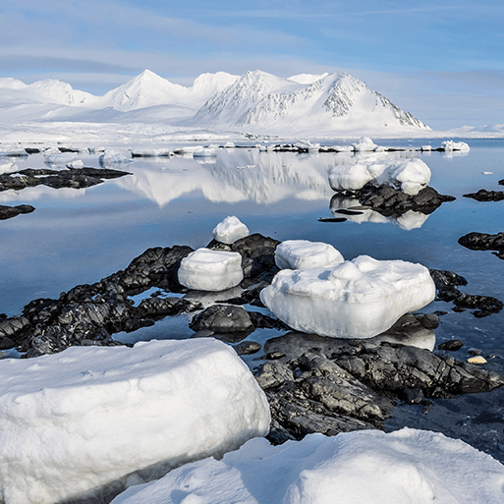  Frozen Kingdom (G)  This projects build on the concept of exploration from Y2 and children learn about the significant achievements of explorers who sailed to polar regions using their knowledge of chronology to build a timeline. They study Scott on his expedition to the South Pole and causes and consequences. They study Shackleton and his team as well as learning about the sinking of the Titanic. | 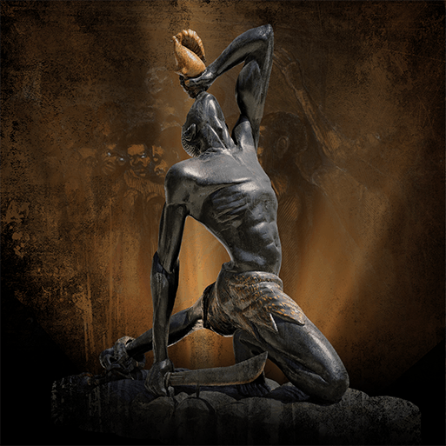  Maafa (H)  This project teaches children about Africa past and present and the development of the slave trade. It also explores Britain’s role in the transatlantic slave trade, the causes and consequences of the European colonisation of Africa and the worldwide communities that make up the African diaspora.  Liverpool Museum of slavery

