Autumn | Spring | Summer
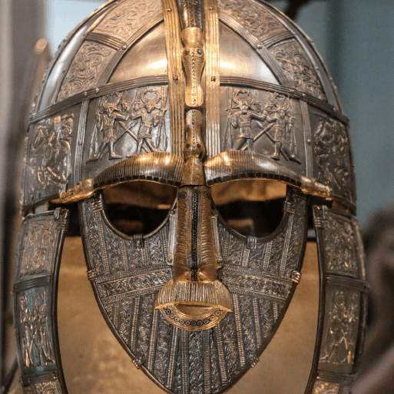  Invasion (H)  This project teaches children about life in Britain after the Roman withdrawal. Children will learn about Anglo-Saxon and Viking invasions up to the Norman conquest.  Viking Workshop | 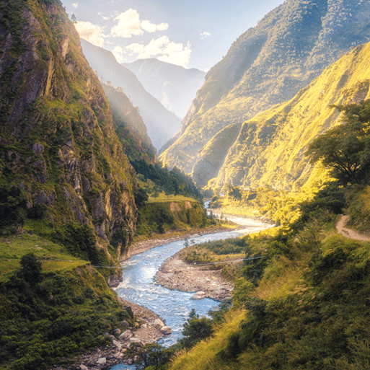  Misty Mountain,Winding River (G)  Ribchester Museum, Bath House and River. | 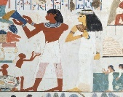  Ancient Civilisations (H)  Ancient Civilisations (H)  This project teaches children about the history of three of the world’s first ancient civilisations: ancient Sumer, ancient Egypt and the Indus Valley civilisation. Children will learn about the rise, life, achievements and eventual end of each civilisation.  Ancient Civilisation Workshop

