Autumn | Spring | Summer
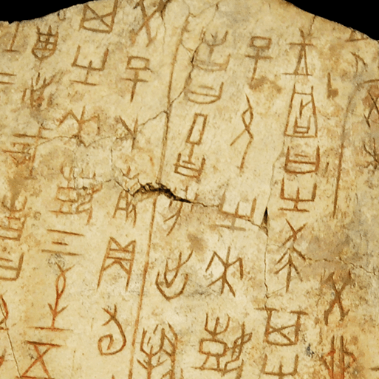  Dynamic Dynasties (H)  This project teaches children about the history of ancient China, focusing primarily on the Shang Dynasty, and explores the lasting legacy of the first five Chinese dynasties, some of which can still be seen in the world today. | 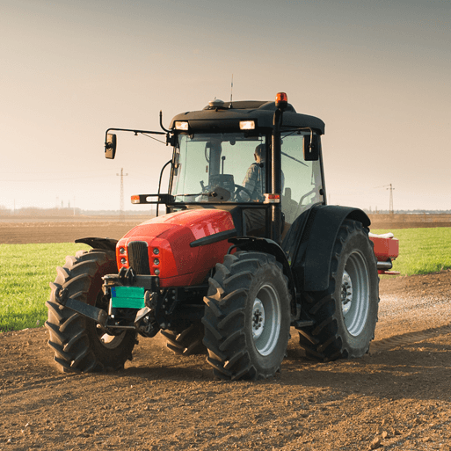  Sow, Grow, Farm(G)  This project teaches children to learn about the historical campaign ‘Dig for Victory’ from WW2 using a range of sources. They learn about the principles behind it and the importance of people growing food to support the war effort. | 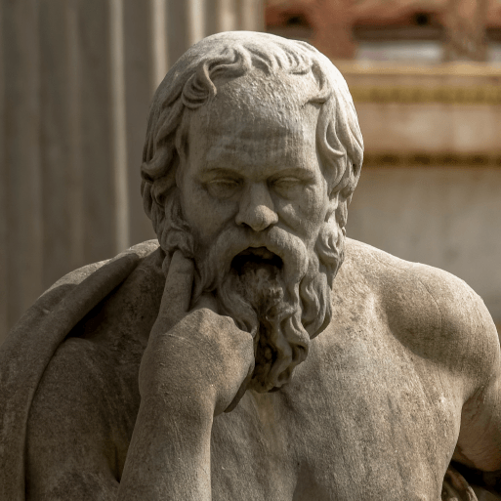  Groundbreaking Greeks (H)  This project teaches children about developments and changes over six periods of ancient Greek history, focusing on the city state of Athens in the Classical age, and exploring the lasting legacy of ancient Greece.  Liverpool Walker Art Gallery

