Autumn |  | Spring |  | Summer
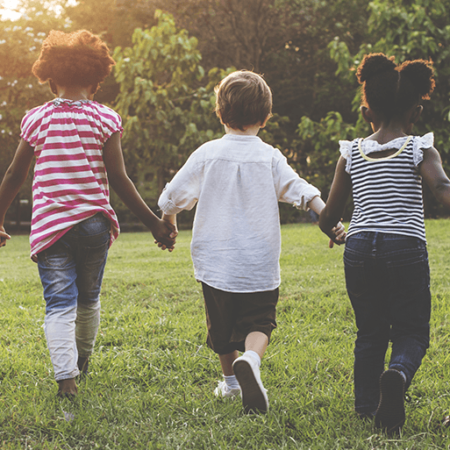 | 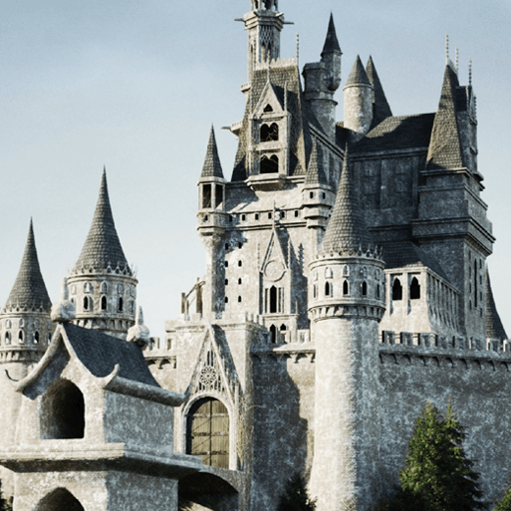 |  | 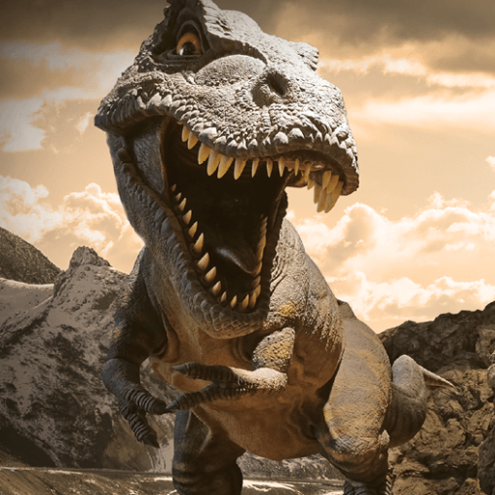 | 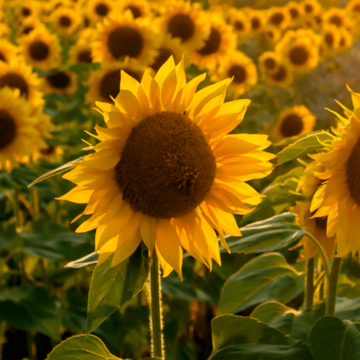 | 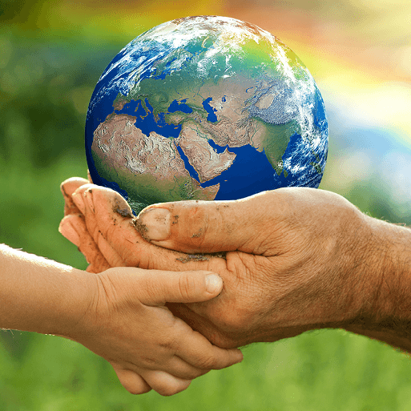
Me and My Community.  In this project, children explore their family history and look at how they have changed since being babies. Children look at the vocabulary of time. They learn about the lives of people in their community and society. | Once Upon A Time.  In this project, children are introduced to the theme of monarchy and royalty and find out about kings and queens in stories. They begin to compare life in the past with their lives by looking at artefacts. | Starry Night.  In this project they are introduced to significant historical figures and events when they learn about Neil Armstrong and the first moon landing. | Dangerous Dinosaurs.  This exciting project teaches children about the different animals that roamed Earth millions of years ago and how they are related to animals that live on Earth today.  Blackpool Zoo - Dinosaurs | Sunshine and Sunflowers. | Big, Wild, World.  In this project children learn  about significant figures.  They explore how life and transport were different in the past. They continue to learn about their family history and introduced to the concept of heritage

